Reports Menu/EasyPay/Patient Summary

Request:

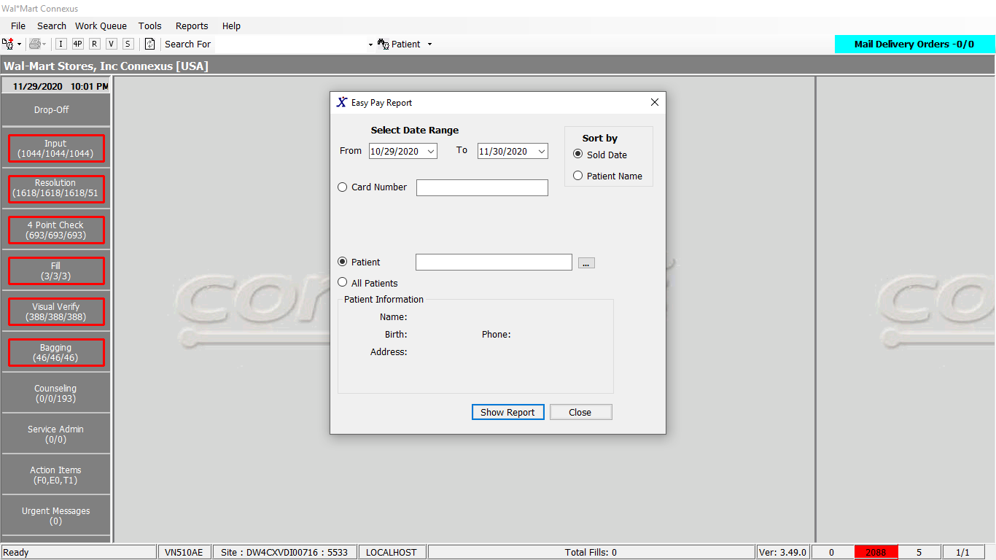

Response 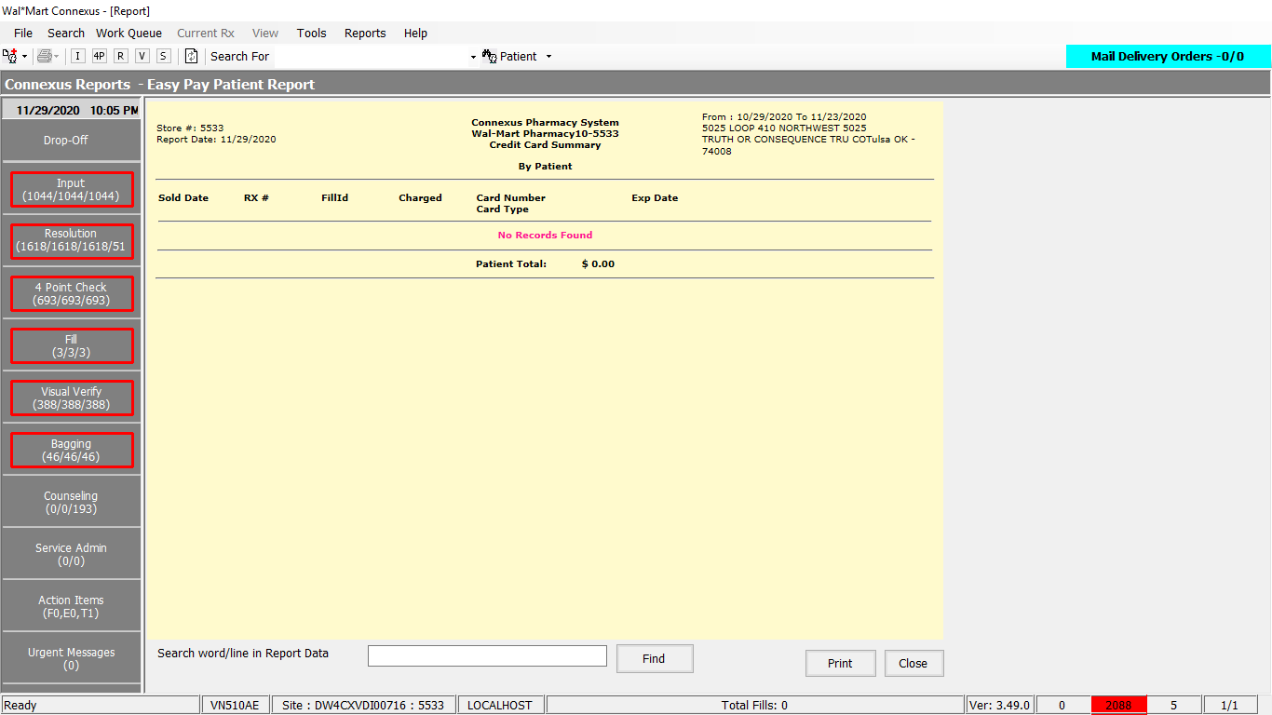

SQL:

sqlString.Append("SELECT pcc1.phm_pymt_acct_id, pp.card_seq_nbr, ")

If isPci Then

sqlString.Append(" card_ref_nbr, card_suffix_nbr , ")

Else

sqlString.Append(" account_nbr, ")

End If

sqlString.Append(ReportQueries.GetEasyPayInfoCustomerSelect)

paramList.Add(ParameterHelper.BuildParameter("paymentStatusCode", DbType.Int16,

ServicesCommonConstants.EasyPayResponsePaid))

paramList.Add(ParameterHelper.BuildParameter("paymentDate", DbType.Date,

startDate))

paramList.Add(ParameterHelper.BuildParameter("paymentDate", DbType.Date,

endDate))

paramList.Add(ParameterHelper.BuildParameter("paymentStatusCode", DbType.Int16,

ServicesCommonConstants.EasyPayResponsePaid))

If Not acctNbr Is Nothing AndAlso acctNbr <> "" Then

If isPci Then

sqlString.Append(" AND pcc1.card_ref_nbr = ? ")

paramList.Add(ParameterHelper.BuildParameter("cardReferenceNbr", DbType.Decimal,

CDec(acctNbr)))

Else

sqlString.Append(" AND pcc1.account_nbr = ? ")

paramList.Add(ParameterHelper.BuildParameter("accountNbr", DbType.String,

acctNbr))

End If

End If

If patientId <> 0 Then

sqlString.Append(" AND pp.patient_id = ? ")

paramList.Add(ParameterHelper.BuildParameter("patientId", DbType.Int32,

patientId))

Else

sqlString.Append("AND pp.patient_id = (SELECT MIN(pp2.patient_id) FROM patient_payment pp2 WHERE pp2.phm_pymt_acct_id = pp.phm_pymt_acct_id) ")

End If

If sort = 0 Then ' by default SOLD DATE AND PATIENT NAME

sqlString.Append(" ORDER BY rfp.payment_date,6 ")

Else

sqlString.Append(" ORDER BY 6,rfp.payment_date ") ' patient name and sold date

End If

Dim dataReader As IDataReader = ExecuteReader(DatabaseEnum.rx21c, siteId,

sqlString.ToString, paramList)

Friend Const GetEasyPayInfoCustomerSelect As String = " expir_year_nbr, expir_month_nbr, TRIM(p.last_name) || ', ' || TRIM(p.first_name) card_holder_name1, TRIM(p1.last_name) || ', ' || TRIM(p1.first_name) card_holder_name, pcc1.phm_pymt_mthd_code, card_security_nbr, relationship_code, billing_addr_txt,city_name,state_prov_code, postal_code, pp.pymt_freq_code, pp.start_date, pp.revoke_date, pcct.credit_card_name, pcct.card_nbr_digit_qty, rx.rx_nbr, rfp.rx_fill_id, rfp.payment_date, rfp.payment_amt, pp.signature_freq_cd, pcc1.routing_nbr, pcc1.phone_nbr, pp.phm_signature_id, pp.patient_id, rx.rx_id, rx.rx_version_seq_nbr,rxf.pos_ts,posa.pos_txn_type_code,posa.pos_post_mthd_code FROM phm_pymt_acct pcc1, patient_payment pp, phm_pymt_mthd pcct, patient p, patient p1, rx_fill rxf, rx, rx_fill_payment rfp,OUTER pos_activity posa WHERE pcc1.phm_pymt_acct_id = pp.phm_pymt_acct_id AND pcct.phm_pymt_mthd_code = pcc1.phm_pymt_mthd_code AND rfp.phm_pymt_acct_id = pcc1.phm_pymt_acct_id AND rxf.rx_fill_id = rfp.rx_fill_id AND rx.rx_id = rxf.rx_id AND rfp.pymt_status_code = ? AND rfp.payment_date BETWEEN ? AND ? AND rfp.payment_seq_nbr = (SELECT NVL(MAX(payment_seq_nbr),0) FROM rx_fill_payment rfp2 where rfp2.rx_fill_id = rfp.rx_fill_id AND rfp2.pymt_status_code = ? ) AND rx.patient_id = p.patient_id AND posa.rx_fill_id = rxf.rx_fill_id AND posa.pos_seq_nbr = (SELECT NVL(MAX(posa1.pos_seq_nbr),0) FROM pos_activity posa1 WHERE posa1.rx_fill_id = posa.rx_fill_id) AND p1.patient_id=pp.patient_id "

DAL:

Public Function GetEasyPayInfoCustomer(ByVal siteId As Integer, ByVal startDate As Date,

ByVal endDate As Date, ByVal isPci As Boolean,

Optional ByVal patientId As Integer = 0,

Optional ByVal acctNbr As String = "",

Optional ByVal sort As Integer = 0) As _

List(Of GetEasyPayInfoCustomerInfoBE) Implements IReportDAL.GetEasyPayInfoCustomer

Using (New Tracer(ConnexusCommonConstants.ConnexusTracer))

Dim sqlString As New StringBuilder

Dim getEasyPayInfoCustBEList As New List(Of GetEasyPayInfoCustomerInfoBE)

Dim paramList As New List(Of DbParameter)

sqlString.Append("SELECT pcc1.phm_pymt_acct_id, pp.card_seq_nbr, ")

If isPci Then

sqlString.Append(" card_ref_nbr, card_suffix_nbr , ")

Else

sqlString.Append(" account_nbr, ")

End If

sqlString.Append(ReportQueries.GetEasyPayInfoCustomerSelect)

paramList.Add(ParameterHelper.BuildParameter("paymentStatusCode", DbType.Int16,

ServicesCommonConstants.EasyPayResponsePaid))

paramList.Add(ParameterHelper.BuildParameter("paymentDate", DbType.Date,

startDate))

paramList.Add(ParameterHelper.BuildParameter("paymentDate", DbType.Date,

endDate))

paramList.Add(ParameterHelper.BuildParameter("paymentStatusCode", DbType.Int16,

ServicesCommonConstants.EasyPayResponsePaid))

If Not acctNbr Is Nothing AndAlso acctNbr <> "" Then

If isPci Then

sqlString.Append(" AND pcc1.card_ref_nbr = ? ")

paramList.Add(ParameterHelper.BuildParameter("cardReferenceNbr", DbType.Decimal,

CDec(acctNbr)))

Else

sqlString.Append(" AND pcc1.account_nbr = ? ")

paramList.Add(ParameterHelper.BuildParameter("accountNbr", DbType.String,

acctNbr))

End If

End If

If patientId <> 0 Then

sqlString.Append(" AND pp.patient_id = ? ")

paramList.Add(ParameterHelper.BuildParameter("patientId", DbType.Int32,

patientId))

Else

sqlString.Append("AND pp.patient_id = (SELECT MIN(pp2.patient_id) FROM patient_payment pp2 WHERE pp2.phm_pymt_acct_id = pp.phm_pymt_acct_id) ")

End If

If sort = 0 Then ' by default SOLD DATE AND PATIENT NAME

sqlString.Append(" ORDER BY rfp.payment_date,6 ")

Else

sqlString.Append(" ORDER BY 6,rfp.payment_date ") ' patient name and sold date

End If

Dim dataReader As IDataReader = ExecuteReader(DatabaseEnum.rx21c, siteId,

sqlString.ToString, paramList)

Dim getEasyPayInfoCustomerBE As GetEasyPayInfoCustomerInfoBE

While dataReader.Read

getEasyPayInfoCustomerBE = New GetEasyPayInfoCustomerInfoBE

If Not isPci Then

If Not dataReader.IsDBNull(dataReader.GetOrdinal("account_nbr")) Then

getEasyPayInfoCustomerBE.AccountNbr = CInt(dataReader("account_nbr"))

End If

Else

If Not dataReader.IsDBNull(dataReader.GetOrdinal("card_ref_nbr")) Then

getEasyPayInfoCustomerBE.CardRefNbr = Convert.ToDecimal(dataReader("card_ref_nbr"), CultureInfo.InvariantCulture)

End If

If Not dataReader.IsDBNull(dataReader.GetOrdinal("card_suffix_nbr")) Then

getEasyPayInfoCustomerBE.CardSuffixNbr = CInt(dataReader("card_suffix_nbr"))

End If

End If

If Not dataReader.IsDBNull(dataReader.GetOrdinal("billing_addr_txt")) Then

getEasyPayInfoCustomerBE.BillingAddrTxt = CStr(dataReader("billing_addr_txt")).Trim

End If

If Not dataReader.IsDBNull(dataReader.GetOrdinal("card_holder_name")) Then

getEasyPayInfoCustomerBE.CardHolderName = CStr(dataReader("card_holder_name")).Trim

End If

If Not dataReader.IsDBNull(dataReader.GetOrdinal("card_nbr_digit_qty")) Then

getEasyPayInfoCustomerBE.CardNbrDigitQty = CInt(dataReader("card_nbr_digit_qty"))

End If

If Not dataReader.IsDBNull(dataReader.GetOrdinal("card_security_nbr")) Then

If dataReader("card_security_nbr") IsNot Nothing AndAlso Not String.IsNullOrEmpty((dataReader("card_security_nbr").ToString() & String.Empty).Trim) Then

getEasyPayInfoCustomerBE.CardSecurityNbr = CInt(dataReader("card_security_nbr"))

End If

End If

If Not dataReader.IsDBNull(dataReader.GetOrdinal("city_name")) Then

getEasyPayInfoCustomerBE.CityName = CStr(dataReader("city_name")).Trim

End If

If Not dataReader.IsDBNull(dataReader.GetOrdinal("credit_card_name")) Then

getEasyPayInfoCustomerBE.CreditCardName = CStr(dataReader("credit_card_name")).Trim

End If

If Not dataReader.IsDBNull(dataReader.GetOrdinal("expir_year_nbr")) Then

getEasyPayInfoCustomerBE.ExpiryYearNbr = CInt(dataReader("expir_year_nbr"))

End If

If Not dataReader.IsDBNull(dataReader.GetOrdinal("expir_month_nbr")) Then

getEasyPayInfoCustomerBE.ExpiryMonthNbr = CInt(dataReader("expir_month_nbr"))

End If

If Not dataReader.IsDBNull(dataReader.GetOrdinal("card_holder_name")) Then

getEasyPayInfoCustomerBE.CardHolderName = CStr(dataReader("card_holder_name")).Trim

End If

If Not dataReader.IsDBNull(dataReader.GetOrdinal("payment_amt")) Then

getEasyPayInfoCustomerBE.PaymentAmt = Convert.ToDecimal(dataReader("payment_amt"), CultureInfo.InvariantCulture)

End If

If Not dataReader.IsDBNull(dataReader.GetOrdinal("payment_date")) Then

getEasyPayInfoCustomerBE.PaymentDate = CDate(dataReader("payment_date"))

End If

If Not dataReader.IsDBNull(dataReader.GetOrdinal("phm_pymt_acct_id")) Then

getEasyPayInfoCustomerBE.PhmPaymentAcctId = CInt(dataReader("phm_pymt_acct_id"))

End If

If Not dataReader.IsDBNull(dataReader.GetOrdinal("phm_pymt_mthd_code")) Then

getEasyPayInfoCustomerBE.PhmPaymentMethodCode = CInt(dataReader("phm_pymt_mthd_code"))

End If

If Not dataReader.IsDBNull(dataReader.GetOrdinal("phm_signature_id")) Then

getEasyPayInfoCustomerBE.PhmSignatureId = CInt(dataReader("phm_signature_id"))

End If

If Not dataReader.IsDBNull(dataReader.GetOrdinal("phone_nbr")) Then

getEasyPayInfoCustomerBE.PhoneNbr = CStr(dataReader("phone_nbr")).Trim

End If

If Not dataReader.IsDBNull(dataReader.GetOrdinal("pos_post_mthd_code")) Then

getEasyPayInfoCustomerBE.PosPostMethodCode = CInt(dataReader("pos_post_mthd_code"))

End If

If Not dataReader.IsDBNull(dataReader.GetOrdinal("postal_code")) Then

getEasyPayInfoCustomerBE.PostalCode = CStr(dataReader("postal_code")).Trim

End If

If Not dataReader.IsDBNull(dataReader.GetOrdinal("pos_ts")) Then

getEasyPayInfoCustomerBE.PosTs = CDate(dataReader("pos_ts"))

End If

If Not dataReader.IsDBNull(dataReader.GetOrdinal("pos_txn_type_code")) Then

getEasyPayInfoCustomerBE.PosTxnTypeCode = CInt(dataReader("pos_txn_type_code"))

End If

If Not dataReader.IsDBNull(dataReader.GetOrdinal("pymt_freq_code")) Then

getEasyPayInfoCustomerBE.PaymentFreqCode = CInt(dataReader("pymt_freq_code"))

End If

If Not dataReader.IsDBNull(dataReader.GetOrdinal("rx_fill_id")) Then

getEasyPayInfoCustomerBE.RxFillId = CInt(dataReader("rx_fill_id"))

End If

If Not dataReader.IsDBNull(dataReader.GetOrdinal("rx_id")) Then

getEasyPayInfoCustomerBE.RxId = CInt(dataReader("rx_id"))

End If

If Not dataReader.IsDBNull(dataReader.GetOrdinal("rx_nbr")) Then

getEasyPayInfoCustomerBE.RxNbr = CInt(dataReader("rx_nbr"))

End If

If Not dataReader.IsDBNull(dataReader.GetOrdinal("start_date")) Then

getEasyPayInfoCustomerBE.StartDate = CDate(dataReader("start_date"))

End If

If Not dataReader.IsDBNull(dataReader.GetOrdinal("state_prov_code")) Then

getEasyPayInfoCustomerBE.StateProvCode = CStr(dataReader("state_prov_code")).Trim

End If

If Not dataReader.IsDBNull(dataReader.GetOrdinal("patient_id")) Then

getEasyPayInfoCustomerBE.PatientId = CInt(dataReader("patient_id"))

End If

getEasyPayInfoCustBEList.Add(getEasyPayInfoCustomerBE)

End While

If getEasyPayInfoCustBEList.Count > 0 Then

Return getEasyPayInfoCustBEList

Else

Return Nothing

End If

End Using

End Function